**Project**

**Day 1**

**Capstone**

**Setup Filebeat**

Run the following commands:

* filebeat modules enable apache
* filebeat setup

**Setup Metricbeat**

Run the following commands:

* metricbeat modules enable apache
* metricbeat setup

**Setup Packetbeat**

Run the following command:

* packetbeat setup

Restart all 3 services. Run the following commands:

* systemctl restart filebeat
* systemctl restart metricbeat
* systemctl restart packetbeat

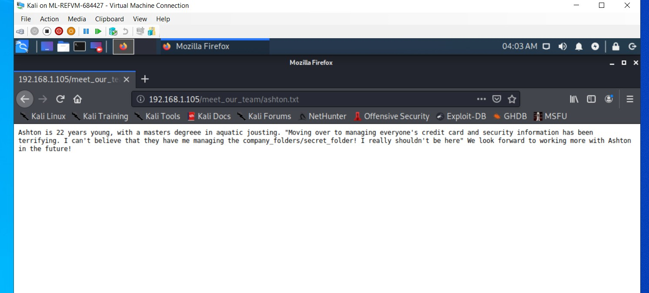Discover the IP address of the Linux web server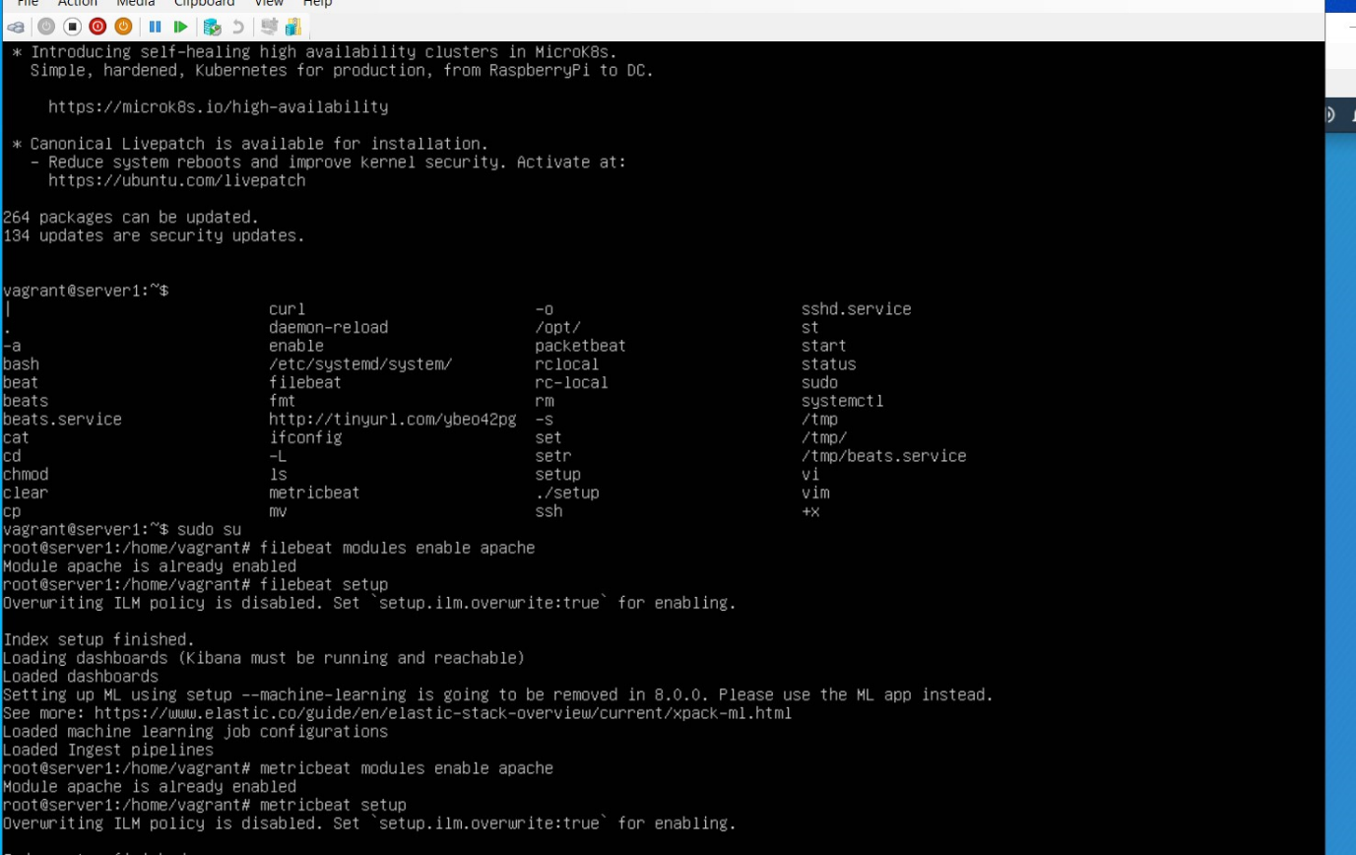 : 80

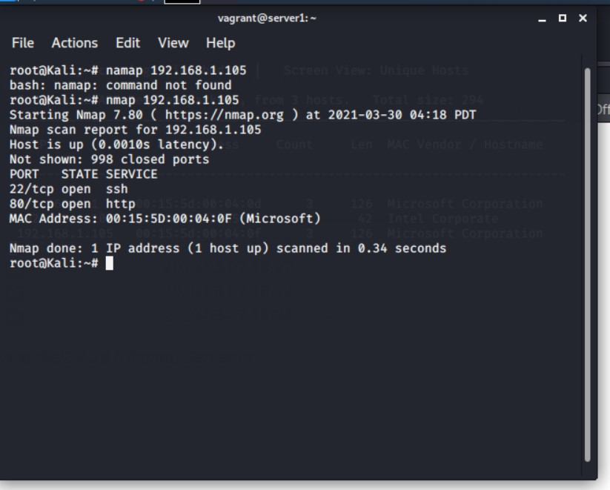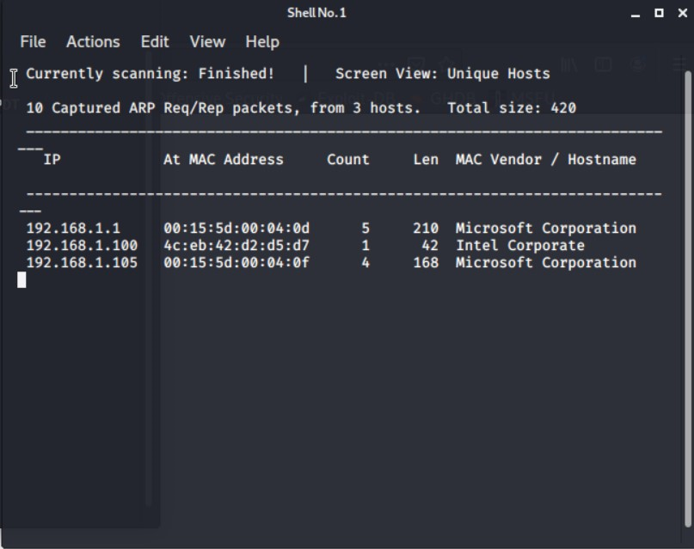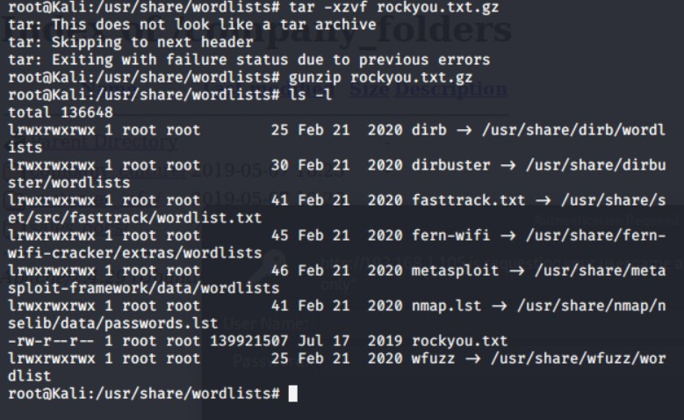

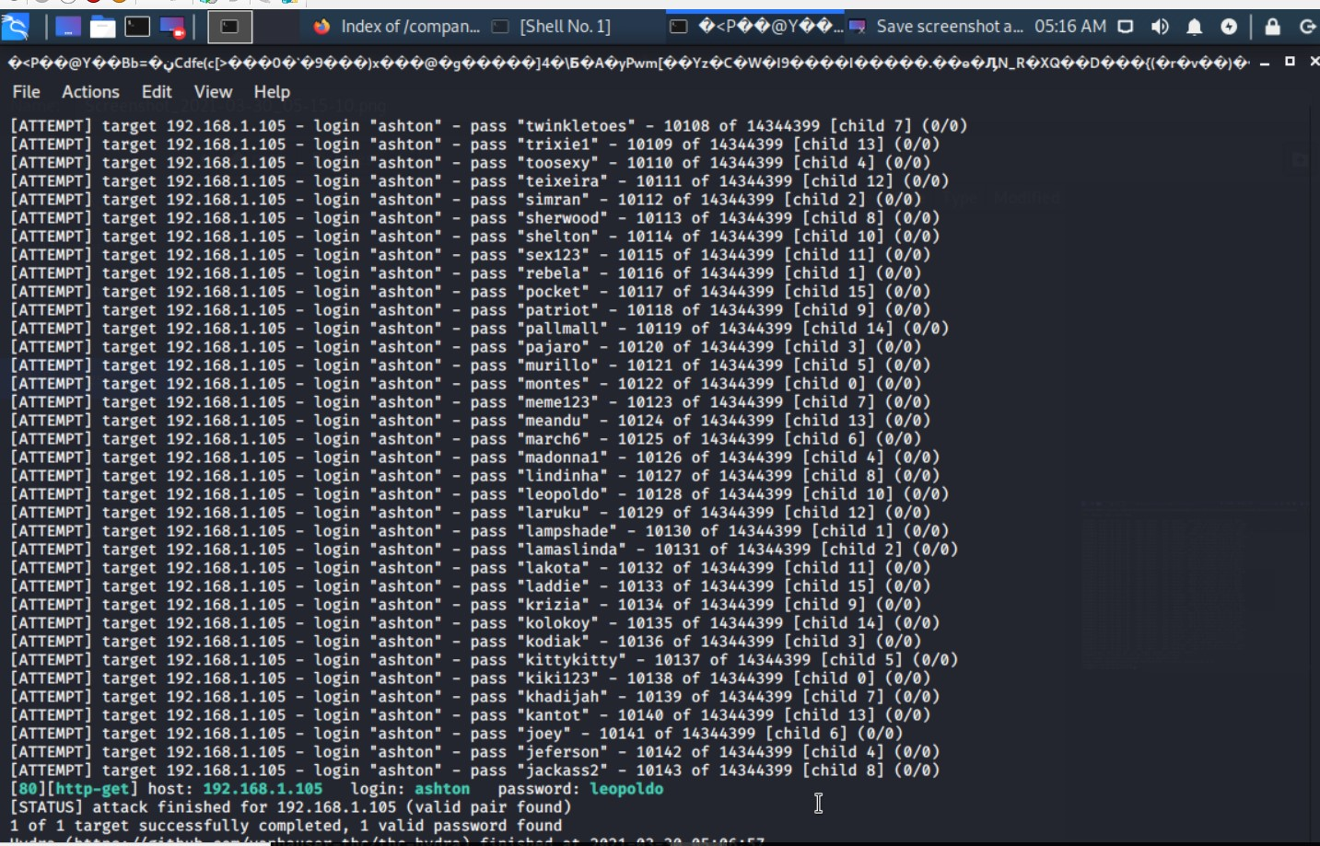

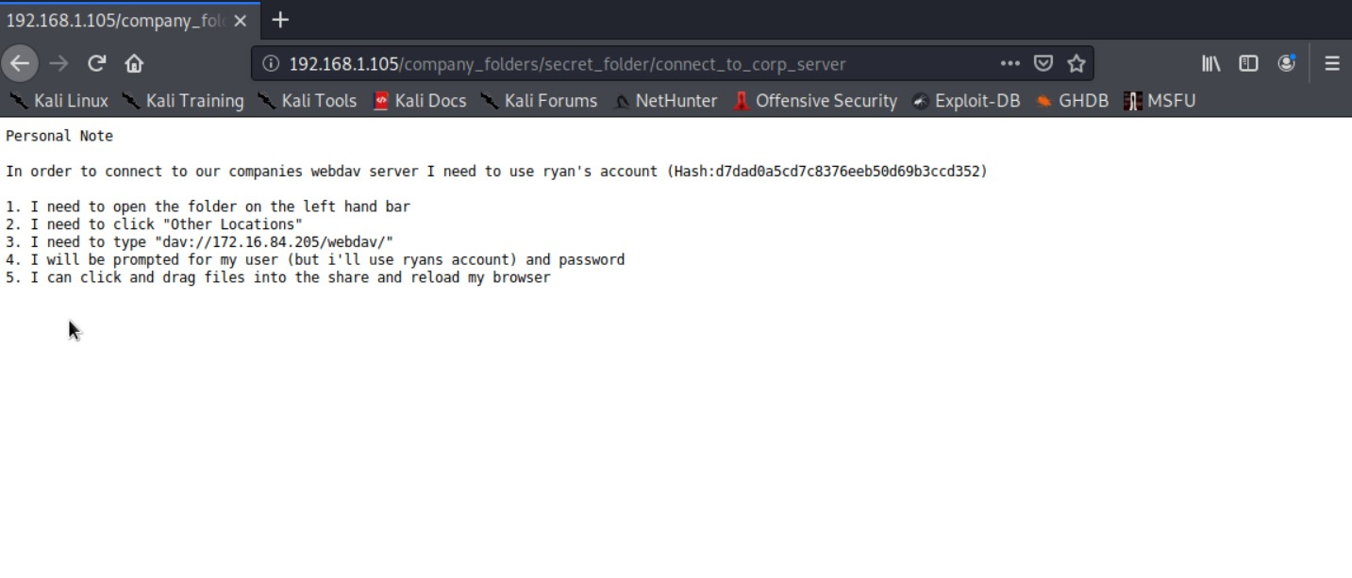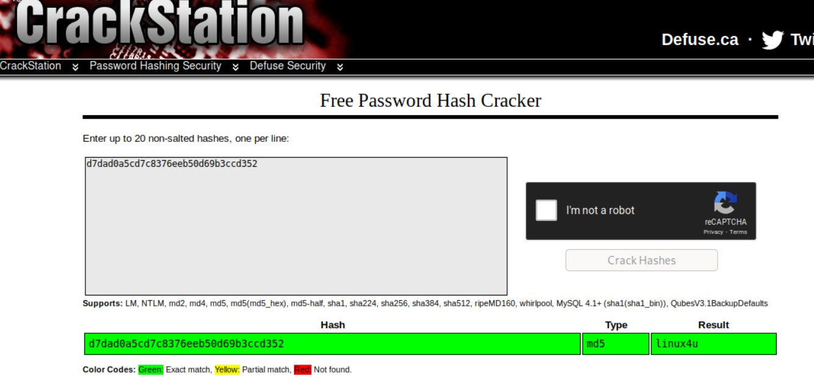

**Flag**

